Inventory Management
This document explains the overview of inventory management functions and features which are available to the users at National, Provincial and District level.
In this document, you will learn about:
- Inventory Management Overview
- Receiving Stock
- Batch Management
- Issuing Stock
- Adding Adjustments

Inventory Management Overview
The inventory Management feature enables the users to manage the inventory for the respective store/facility, and also issue and receive stock based on demand to other health facilities in order to ensure an uninterrupted supply of family planning commodities. However, the features in inventory management module are rights based.
The central warehouse user can perform the following functions:
- Stock Receive (Supplier): Users can receive stock from other stores.
- Stock Receive (Warehouse): Users can receive stock from other warehouses.
- Stock Receive - Search: users can search the received stock from other stores or suppliers.
- Placement Locations: users can specify the placement locations for the stock.
- Location Status: users can view the status of a location in the warehouse using this option.
- Batch Management: When stock is received, user can manage, and view vaccines batches priorities based on expiry and VVM stage and for dry store products can view priority based on expiry date.
- Stock Issue: The stock is issued to other stores on demand.
- Stock Issue – Search: User can search for the issued stock.
- Stock Pick: Users can use the stock pick feature to pick up stock.
- New Adjustment: you can add adjustments for your stock in case of wastages, breakage or pilferages.
- Search Adjustment: User can search the added adjustments for a selected duration.
- Bin Card: users can view the bin card using this feature.
- District Distribution Plan: user can create a distribution plan for the district.

Stock Receive (Supplier)
User at the Central level can receive stock directly from the supplier. Users can also add information such as Funding Source, Product, Manufacturer, Batch No, Expiry Date and Quantity of the required product.
To receive stock from supplier:
- In the side-menu, click Inventory Management and then click Stock Receive from Store.
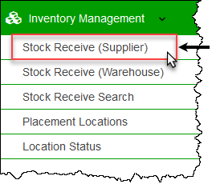
The Stock Receive (Supplier) screen displays.
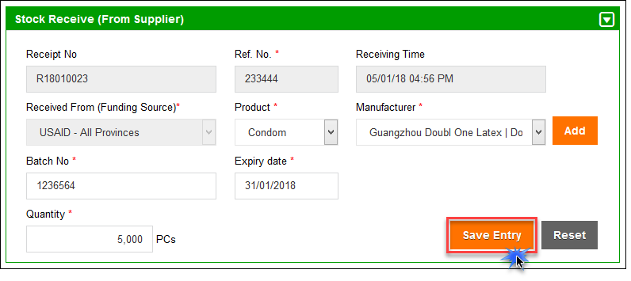
- Specify the following information:
  - Ref. No.: enter the reference number of the received stock.
  - Receiving Time: specify the time of receiving.
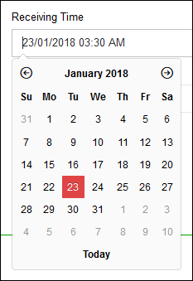
  - Received from (Funding Source): specify the funding source of the shipment.
  - Product: specify the product.
  - Manufacturer: specify the manufacturer.
  - Batch No.: specify the batch number.
  - Expiry Date: specify the expiry date.
  - Quantity: specify the quantity.

- Click Save Entry.
The entry moves to the Receive List.
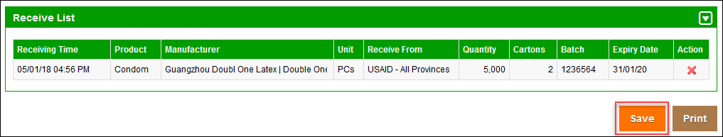
- A confirmation box displays.
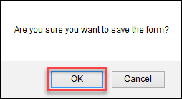
- Click OK to receive the entry.

Stock Receive (Warehouse)
The Central warehouse user can receive the stock being issued by other warehouses such as at the provincial or district levels. Storekeepers will be able to receive products against the issue voucher number provided by the issuing authority.
To receive stock from another store:
- In the side-menu, click Inventory Management and then click Stock Receive from Store.
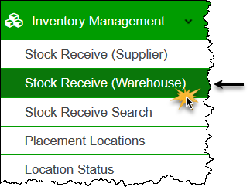
The Stock Receive (From Warehouse) screen displays.
- In the Issue No text box, specify the issue number and then click Search.
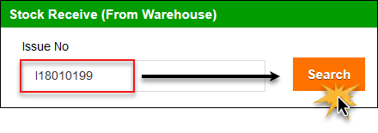
The Issue details are populated.
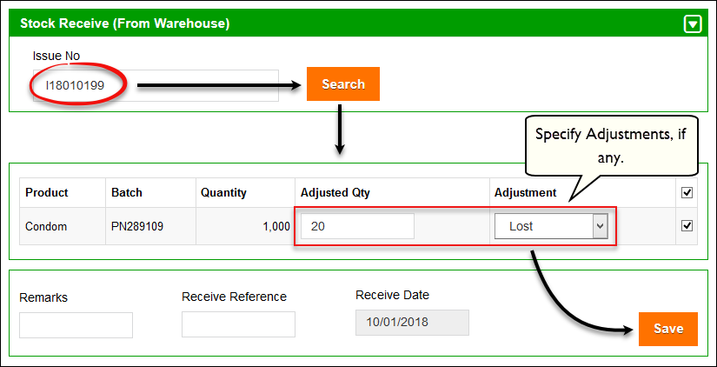
- Review the following information:
  - Product: displays the product.
  - Batch: displays the batch number
  - Quantity: displays the quantity.
  - Adjusted Quantity: you can specify the adjusted quantity in this text-box, if any.
  - Adjustment: specify the type of adjustment.
  - : In case of multiple issue entries, you can check the required issue entry you want to receive.
  - Remarks: enter the remarks.
  - Receive Reference: enter the receive reference.
  - Receive Date: use the date picker tool to enter the receive date of the stock.
- Click Save.
A confirmation box displays.
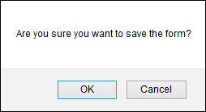
- Click OK to receive the entry.

Stock Receive – Search
LMIS facilitates the user to search for a received stock entry.
To do so:
- In the side-menu, click Inventory Management and then click Stock Receive Search.
The Stock Receive Search page displays.
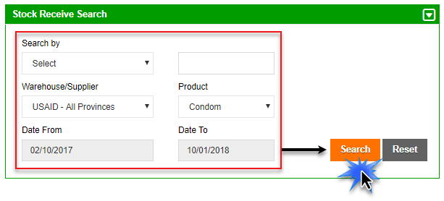
- Specify the following filters:
  - Search By: Specify the unique identifier you want to search by. The options include:
    - Receive No: if you know the receive number, select this option and specify the Receive No in the adjacent text box.
    - Receive Ref.: To search using the Receive Ref, select this option and then specify the Receive Ref in the adjacent text box.
    - Batch No: To search using the Batch No., select this option and then specify the Batch No in the adjacent text box.
  - Warehouse/Supplier: you can select the store/supplier, as required.
  - Product: select the required product from the list.
  - Date From, Date To: Click on date to expand the date picker tool.
- Click Search to populate the required entries in the Receive List, as shown below.
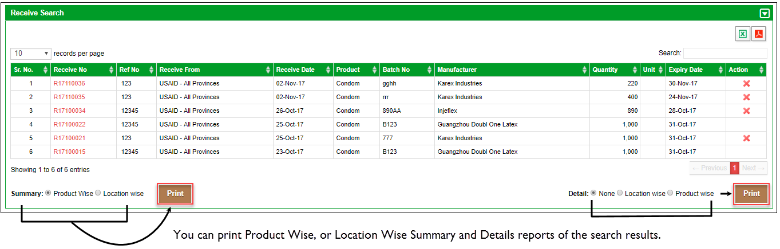
- You can print the following reports:
  - Summary Reports: You can print a product wise summary report or a location wise summary report of the search results.
  - Detail Reports: You can print a product wise detailed report, a location wise detailed report or a default detailed report of the search results.
- Click Print to print the report.
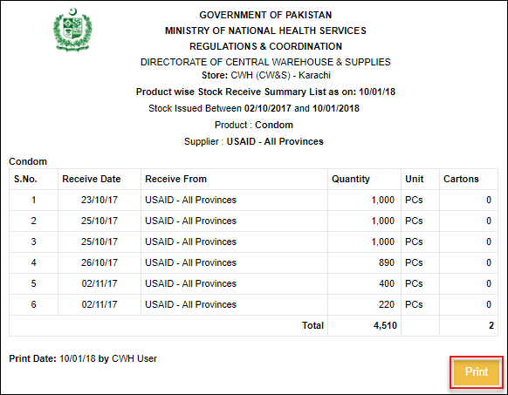

Placement Locations
The Placement Location tab under Inventory Management enables you to add and manage placement locations for the stock within the store by adding location Area, Row, Rack, Rack Type, Pallet, and Level.
To manage locations for the stock within the store, select the following filters:
- Click Placement Location under Inventory Management.
The Manage Locations page displays.
- In the Manage Locations (Bins), specify each of the following mandatory filter options:
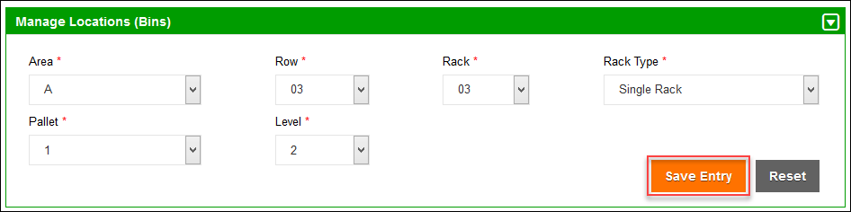
- Area: Select the store number from the list.
- Row: Select the row number for the location.
- Rack: Select the rack number from the list.
- Rack Type: Select the rack type from the list.
- Pallet: Select the pallet from the list.
- Level: Select the level from the list.
- Click Save Entry.
The entry moves to the Location List.
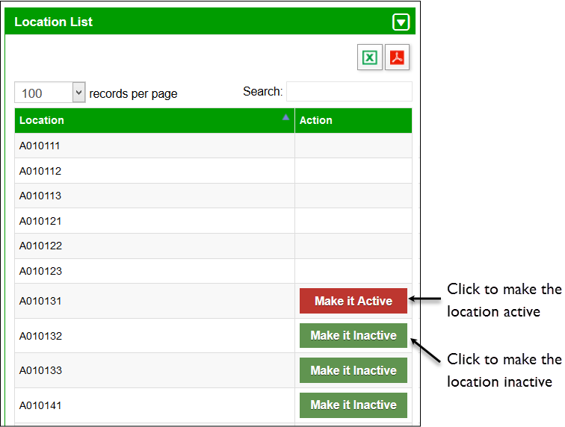

Location Status
Users can select Location Status to view different placement locations for the stock.
To access the Store Locations:
- Click Location Status under Inventory Management.
The Location Status page displays.
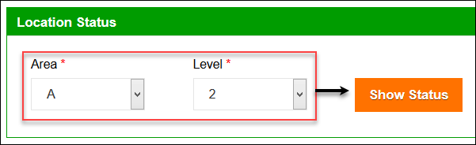
- Specify the following:
- Area: Select the area number from the list.
- Level: Select the level number for the location.
- Click Show Status.
The stock placed in the selected area and level will be displayed. Refer to the legends to understand the capacity status of each bin.
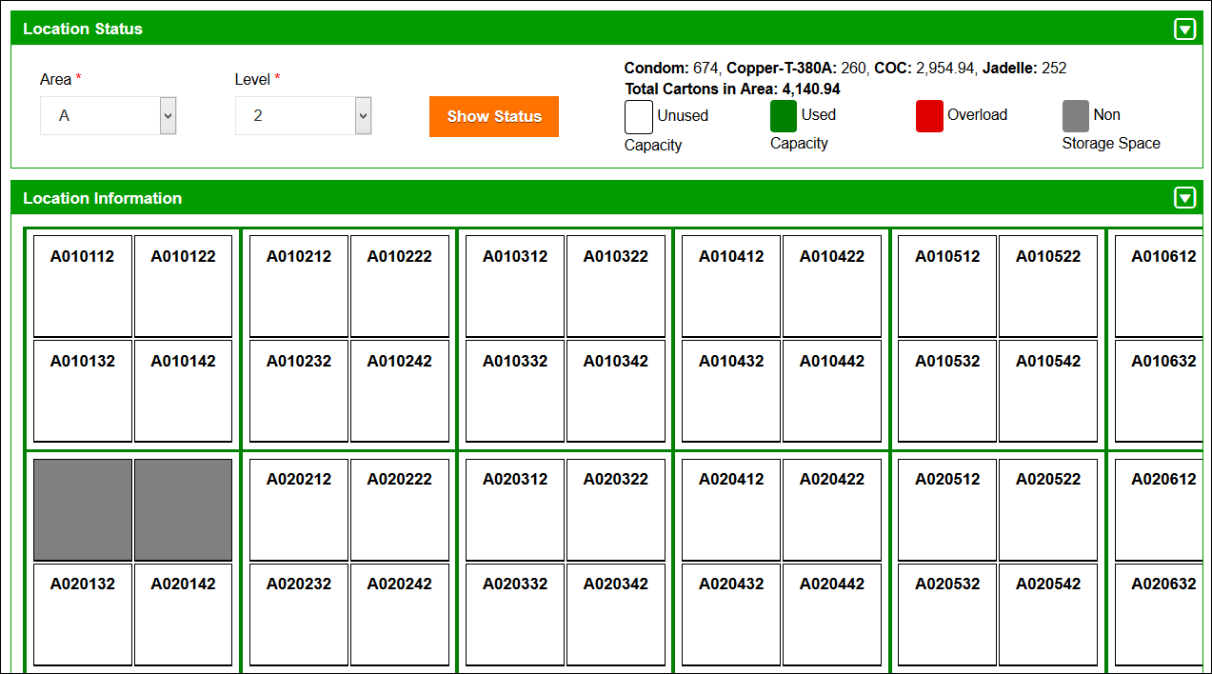
- Click the required bin in the rack.
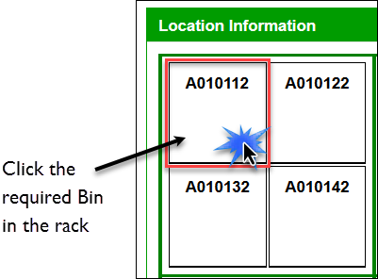
The Stock in Bin page displays the dry items placed in the selected bin.
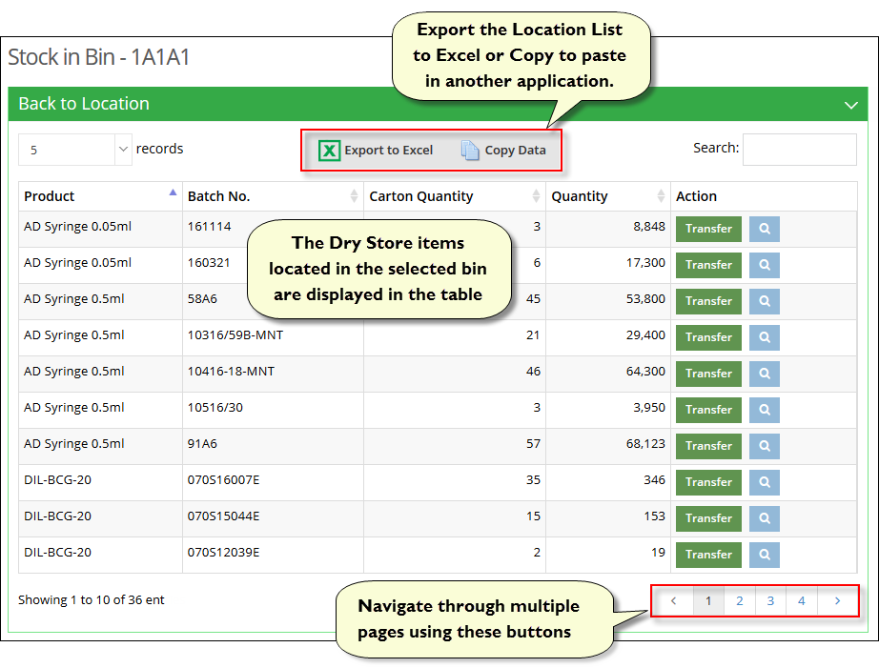
 | Click to export the list of stock available to an excel file. You can also click to copy the data of available stock and paste them to another application.
- View the required row in the table for the following information:
- Product: displays the name of the product placed in the bin.
- Batch Number: displays the batch number of the product placed in the bin.
- Carton Quantity: displays the carton quantity of the product placed in the bin.
- Quantity: displays the quantity of the product placed in the bin.
- Action: You can transfer the dry item to another bin by clicking Transfer.
Each batch can be divided in multiple quantities and placed in multiple bins. You can click the Search icon to search for the placement of all of the batch items for the selected product.
- To transfer stock to another bin location, click Transfer.
The Transfer Stock dialog displays.
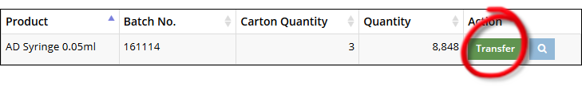
The following information is displayed:
- Product: displays the name of the product (read-only).
- Batch Number: displays the batch number (read-only)
- Available Quantity: displays the available quantity in the bin (read-only).
- Location: to transfer the product to another bun, select the location of the bin from the Location drop-down list.
- Quantity: specify the quantity to be transferred to the new location.
- Click Transfer to transfer to selected stock to another bin.
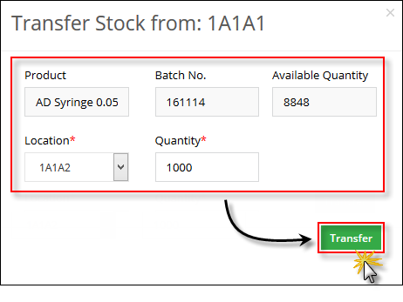
- Click to search for the placement of the entire batch of the selected product.
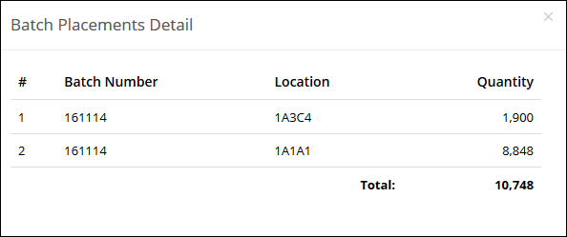
Each batch can be divided in multiple quantities and placed in multiple bins. You can view the placement of the batch items for the selected product in the Batch Placement Details dialog.

Batch Management
Once the stock is received at a warehouse, each package is identified by its Batch Number and Expiry Date. Each batch is sorted by its expiry date by the rule of “First Expiry First Out”. When batches of stock are added to the cLMIS, the account user usually assigns the batches with latest (nearest expiry) expiry date as ‘Running’. The running batches are issued first. The cLMIS provides a section for batch management of each product. Each batch will have a status i.e. Running, Stacked, and Finished. Central users will be able to change the status of batches as desired.
Stock can be issued only if their batch status is set to Running by the system. One or more batches can be set to running depending on the quantity and expiry date of the product. The system provides a summary of batches of each product with a total quantity.
To manage batches:
- Under Inventory Management, click Batch Management.
The Batch Management page displays.
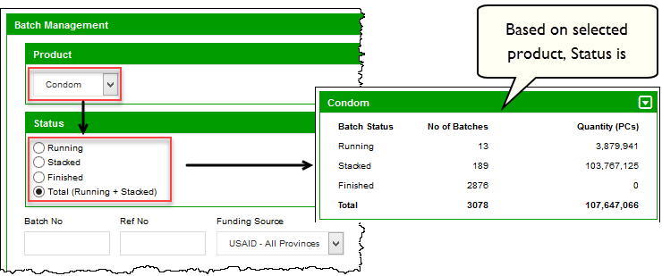
- Use the Search Filters to specify the search criteria. The filter options include:
- By Product: select the required product from the list.
- Batch Number: Specify batch number if you need to search specific batch.
- Ref No:
- Funding Source:
- Status: This filter includes following options.
- Running: filter the running stacks.
- Stacked: filter the stacked batches.
- Finished: filter the finished batches.
- Total (Running + Stacked): filter the total running and stacked batches.
- Click Search to display the search results.
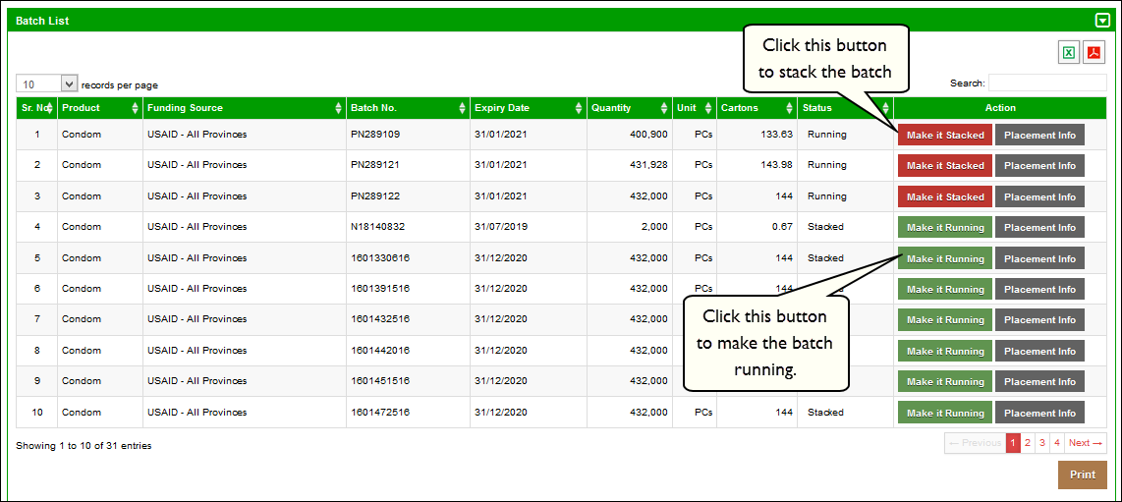
Click to export the search results to an excel file.
You can also click to copy the data of the search results and paste them to another application.
- Click Print to print the report, if required.
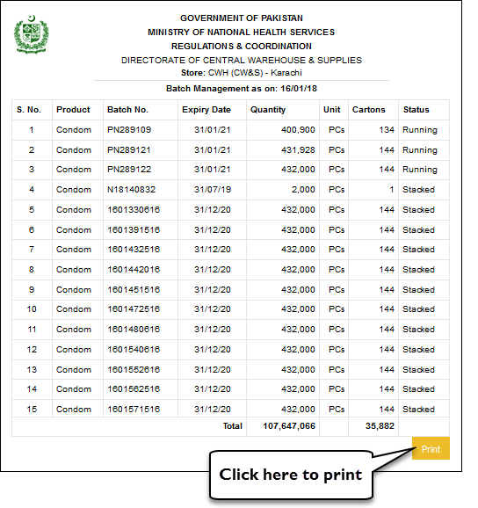

Stock Issue
Central user can issue stock using this option. At National level, the stock issue is based on the districts requisition (CLR-6). Provincial and district storekeepers can also issue the stock back to the respective upper level store if required.
To issue stock:
- Under Inventory Management, click Stock Issue/Dispatch.
The New Issue page displays.
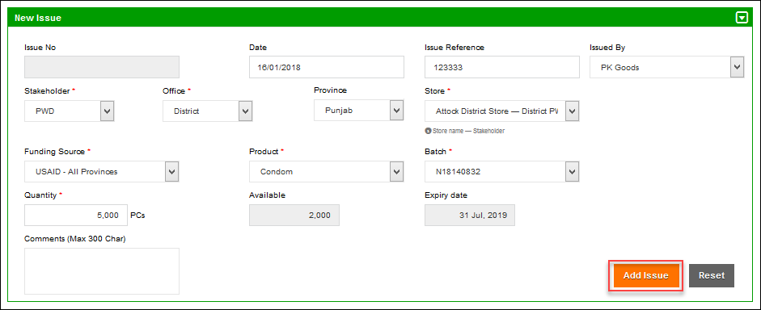
- In order to issue a vaccine batch, specify the following information:
- Issue No: It is an automatically generated number for identifying the Issue transaction. It starts from ‘I’ (i.e. Issuance) with leading 8 digits serial number (e.g. I16020001). In the number I 16 02 0001, I is (Issuance) 16 (last two digit of year) 02 (two digits for month) 0001(No of voucher for the selected month, and this number starts from 0001 for every month).
- Date: Click on Issue date to expand the date picker tool and select issuance date.
- Issue Reference: Specify issue reference.
- Purpose: Specify stock issuance purpose i.e. (Routine, Campaign, IHR and PTP etc.). In case of a campaign, the name of the campaign should also be specified.
- Office (Issue To): In this drop-down, select the office to which you want to issue the product. On selecting the Office, the Province drop-down is displayed. On selecting the Province, the District drop-down is displayed. On selecting the District, the Issue To drop-down displays the relevant store names in the selected province and selected district. Select the required store.
- Product: Select the product from the list.
- Batch: specify the batch from the list.
- Quantity: specify the Issued quantity in vails/pcs.
- Available: Displays batch total available quantity which may be placed at one place or placed in multiple locations.
- Expiry Date: Displays selected batch expiry date.
- Click Add Issue to add the issue entry to the Stock Issue list, as shown below:
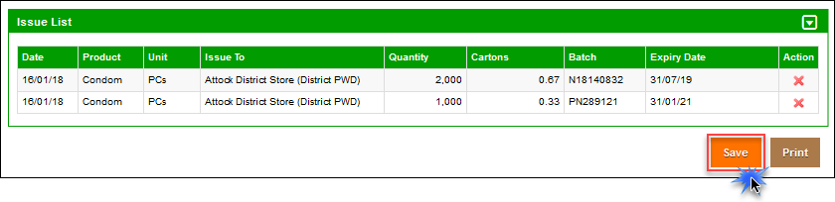
You can click X to delete an entry from the issue list, if required.
- In the Comments box, specify comments if any.
- Specify Issued period.
- Click Save.
The Issue entry is saved.
- Click Print to print the Issue Voucher.

Stock Issue Search
Central user can also search the issued stock by Issue No, Issue Ref, or Batch No. User can also select the Warehouse Supplier and the Product to search a particular stock. The system provides an option to print a filtered search as well as an individual transaction. User can also print stock issue summaries as well as detailed lists of stock being issued based on product and location.
To search for an issue entry:
- Under Inventory Management, click Stock Issue-Search.
The Stock Issue Search page displays.
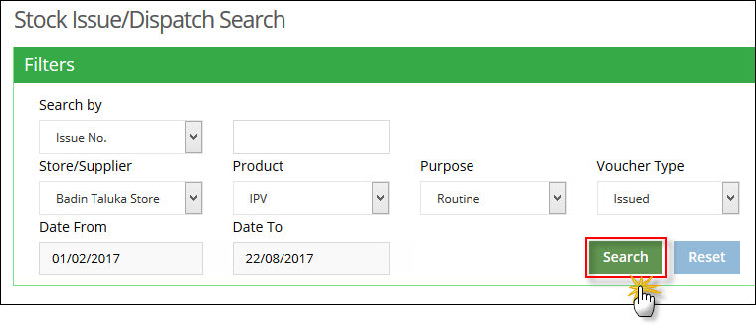
- Specify the following filters:
  - Search By: Specify the unique identifier you want to search by. The options include:
- Issue No: if you know the issue number, select this option and specify the Issue No in the adjacent text box.
- Issue Ref.: To search using the Issue Ref, select this option and then specify the Issue Ref in the adjacent text box.
- Batch No.: To search using the Batch No., select this option and then specify the Batch No in the adjacent text box.
  - Store/Supplier: select the store/supplier. This is optional field.
  - Product: select the required product from the list.
  - Purpose: select the required purpose from the list for which product is being issued.
  - Date From, Date To: Click on date to expand the date picker tool.
- Click Search.
The required entries are displayed in the Issue List.
- Click Print to print the displayed list.

Stock Pick
Central user also has an option to issue stock to other warehouses, provincial stores/facilities as well as field offices. Once a central user issues stock to a district, it is placed at a location within the warehouse. User can manage the placement location of the stock from the Location Status.
 | Remember that in order to issue and pick batches, you have to first set the status to ‘Running’.
The Stock pick feature enables you to pick stock:
To do so:
- Under Inventory Management, click Stock Pick.
The Stock Pick screen displays.
- In Date From, and Date To, specify the date range and then click Search.
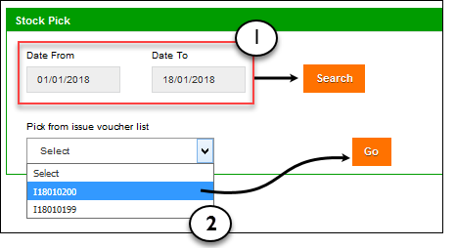
- In Pick from Issue Voucher List specify the Issue Voucher and then click Go.
The issue list is populated, as shown in the image below:
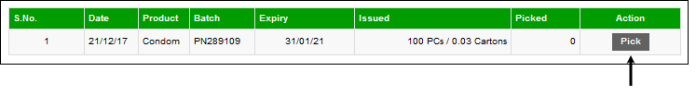
- Click the Pick button.
The Pick from Location dialog displays:
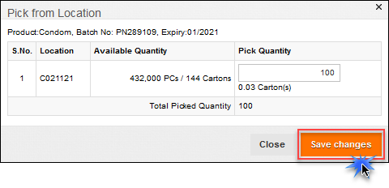
Location specifies the physical location of the batch in the warehouse.
- Specify the Pick Quantity. Make sure you don’t pick more than 100 PCs.
- Click Save Changes.

New Adjustment
To add new Adjustments:
- Under Inventory Management, click Add Adjustment.
The Add Adjustment page displays.
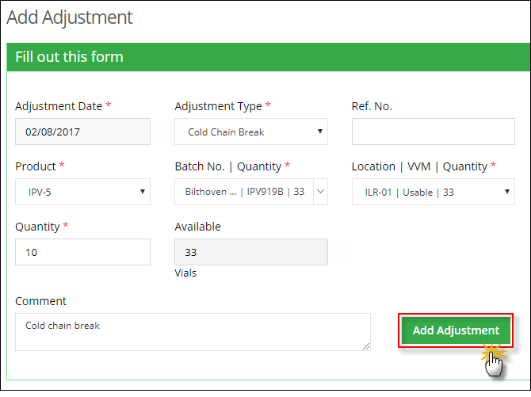
- Specify the following filters:
  - Adjustment Date: Click on date to expand the date picker tool.
  - Adjustment Type: Select adjustment type from the list (damaged, expired, cold chain break, physically found etc.).
  - Ref. No.: Enter the Ref. No. of the adjustment.
  - Product: Select the required product from the list.
  - Batch No. | Quantity: Select the batch number for the selected product, which displays along with its existing quantity.
  - Location | VVM Stage | Quantity: Select add adjustment placement location which is displayed along with location (cold room/IRL) or Bin (Dry store), VVM stage and Quantity.
  - Quantity: specify the quantity to be adjusted.
  - Available: It is read only field and appears on batch selection and shows the available quantity of the selected batch.
  - Comment: Add comments, if any.
- Click Add Adjustment to add the adjustment entry.

Search Adjustments
Every now and then user have to update the number of items in stock manually. This could be due to lost or damaged items or received less inventory than expected. Hence users can add stock adjustments for managing the inventory.
To search for Adjustments:
- Under Inventory Management, click Adjustment-Search.
The Search Adjustments page displays.
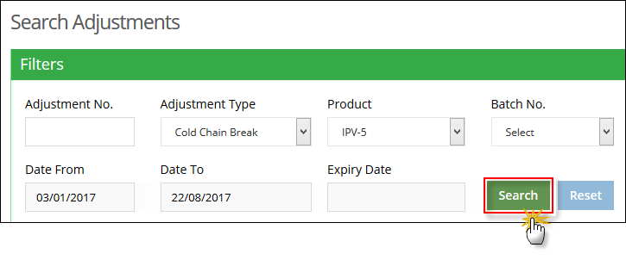
- Specify the search criteria:
  - Adjustment No.: If you know automatically generated unique identifier for the adjustment then specify it.
  - Adjustment Type: specify the adjustment type.
  - Product: select the required vaccine from the list.
  - Batch No: Select the batch number for the selected product, which displays along with its existing quantity.
  - Expiry Date: Select the batch expiry date.
  - Date From, Date To: Click on date to expand the date picker tool.
- Click Search.
The Search result displays.
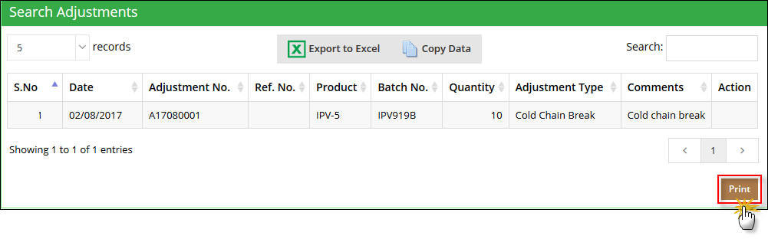
- Click Print button to print searched results.

Bin Card
Central user can view the stock available in a particular Area and Row.
To do so:
- Click Bincard under Inventory Management.
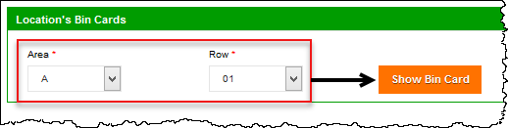
- From the Area drop-down list select an area, and from the Row drop-down list, select a row.
- Click Show Bin Card.
The bin card location will appear.
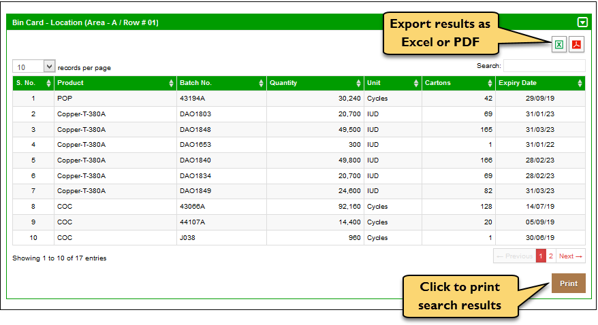
- Click Print to print the list of stock.

District Distribution Plan
Central user can view the stock available in a particular Area and Row.
To do so:
- Click District Distribution Plan under Inventory Management.
- Click to view the issuance trend of the SDP.
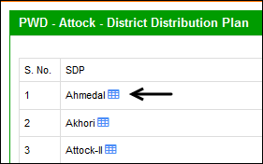
The Stock Issuance Trend displays. Select the required product tab to view the product-wise trend.
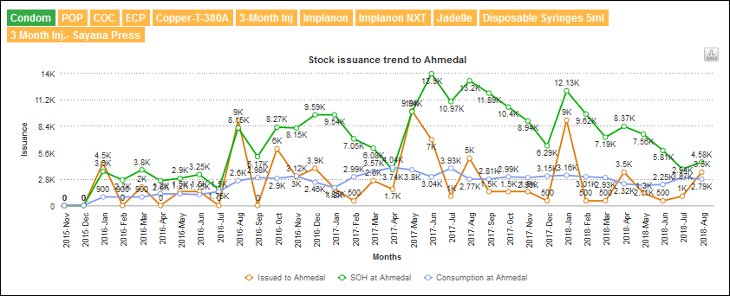
- Under Action, click on Issue.
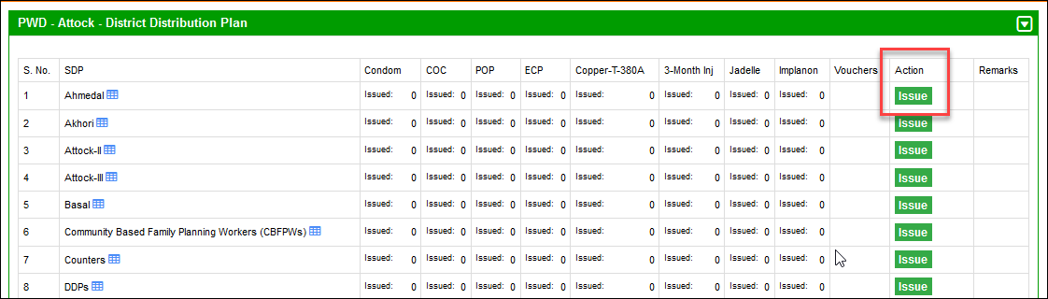
- Click Issue adjacent to the SDP to open the Stock Issuance Form.
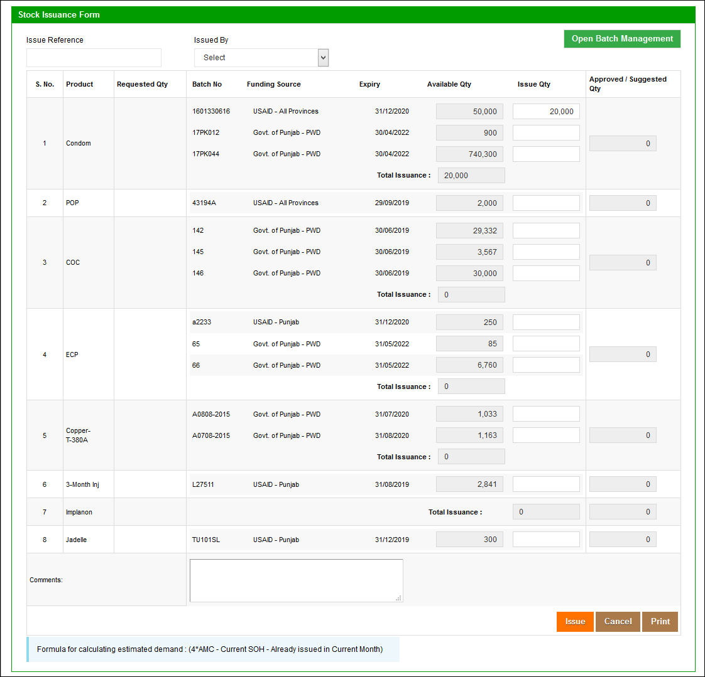
- The user can specify the following options:
- Issue Reference: user can specify the issue reference number.
- Issued By: user can select the issuing authority using the drop-down list.
- The form includes product wise information. The options include:
- Product: displays the available products in the store.
- Requested by: displays the requested quantity by the receiving SDP.
- Batch No.: displays the batch number of the product.
- Funding Source: displays the funding source.
- Expiry: displays the expiry date for each batch of the product.
- Available Qty: displays the available quantity.
- Issue Quantity: Enter the quantity to be issued in this entry box. You can enter quantity from each batch
- Approved/Suggested Qty: displays the approved or suggested quantity.
- Total Issuance displays the sum of issuance from each batch.
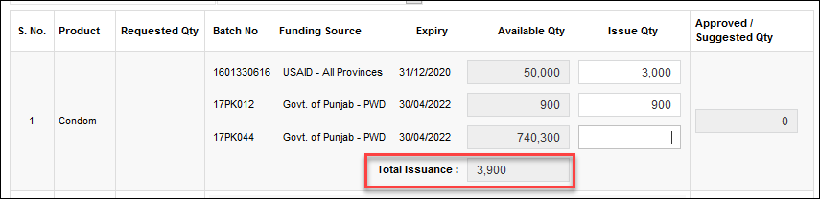
- The user can specify Comments under the products list.
- Click Issue to issue the specified quantity of the product.
- You can click Open Batch Management to open the batch management module. For more information, you may refer to the “Batch Management” section.

